Task 1

Field | Information
Gene Name | TP53
Full Gene Name | Tumor Protein p53
Gene ID | 7157
Gene Function | Tumor suppressor
Accession Number | U94788
Sequence Description | Human TP53 complete coding sequence (CDS)
Sequence Type | DNA (Complete Coding Sequence)
Organism | Homo sapiens
NCBI Database | Nucleotide

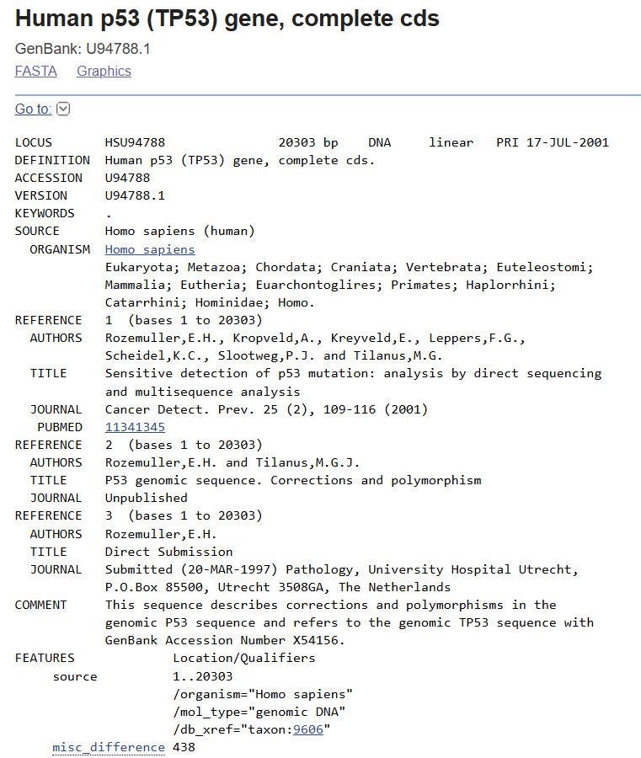

Task 2

- Accession Number: U94788
- Gene ID: 7157
- Sequence: Complete coding sequence (CDS) of the human TP53 gene
- Format Downloaded: FASTA
- Organism: Homo sapiens
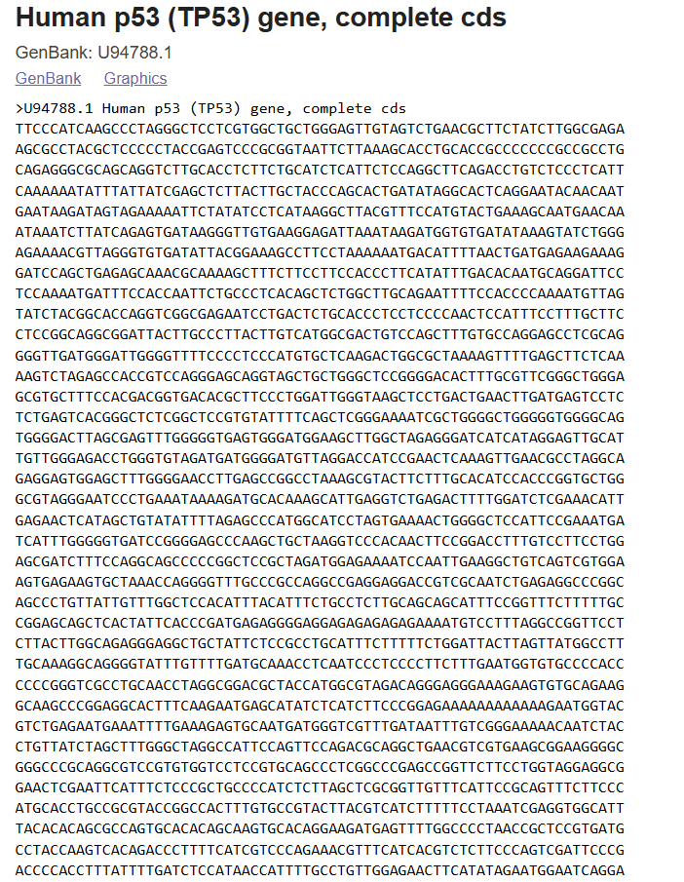

Task 3

Sequence Record: Human p53 / TP53 Gene
Sequence used: Human p53 (TP53) gene, complete cds
GenBank record: U94788.1
1. Accession number
U94788.1
2. Organism
Homo sapiens / Human
3. Molecule type
DNA
It is not RNA or mRNA. The LOCUS section clearly shows DNA, and the record describes the complete coding sequence of the TP53 gene.
4. FEATURES section information
The FEATURES section gives biological annotation of the sequence, such as:
- Source region: bases 1..20303
- Organism: Homo sapiens
- Molecule type: genomic DNA
- Taxonomy ID: taxon:9606
- Gene-related annotations such as TP53 gene region, coding sequence/CDS, and other sequence features if present lower in the record.

TP53 (tumor protein p53) is one of the most researched tumor-suppressor genes in human beings. This gene codes for the p53 protein, which is involved in regulation of the cell cycle, DNA repair processes, apoptosis, and response to cellular stress. As the TP53 gene is responsible for stopping genetic mutations, it is commonly known as the “guardian of the genome.” The genetic mutations in the TP53 gene are some of the most common in human cancer and are important in molecular biology and bioinformatics.
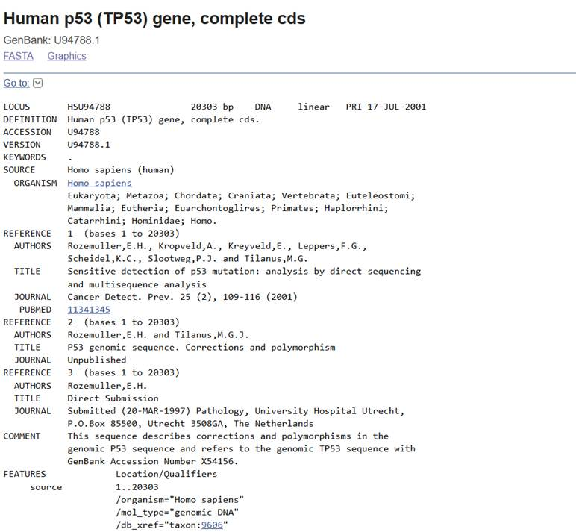

Task 4

BLASTN Analysis
Program used: BLASTN
Database: core_nt
Query sequence: Human p53 / TP53 gene sequence
Query length: 19673 bp
Top 5 BLASTN hits
No. | Hit description | Organism | Query coverage | Percent identity | E-value
1 | Human p53 (TP53) gene, complete cds | Homo sapiens | 100% | 100.00% | 0.0
2 | Homo sapiens p53 gene | Homo sapiens | 100% | 99.94% | 0.0
3 | Homo sapiens tumor protein p53 | Homo sapiens | 100% | 98.74% | 0.0
4 | Mus musculus musculus strain sequence | Mus musculus | 100% | 98.73% | 0.0
5 | Eukaryotic synthetic construct | Synthetic construct | 100% | 98.73% | 0.0

1. Which organism produced the best match after humans?
Mus musculus / mouse produced the best non-human match.
2. Which organism showed the lowest similarity?
From the visible top hits, Mus musculus and the eukaryotic synthetic construct show the lowest percent identity among the top 5, both around 98.73%.
3. What does the E-value indicate?
The E-value shows the probability that the match occurred by random chance.
Here, the E-value is 0.0, meaning the match is extremely significant and not random. Lower E-value means a more reliable BLAST hit.
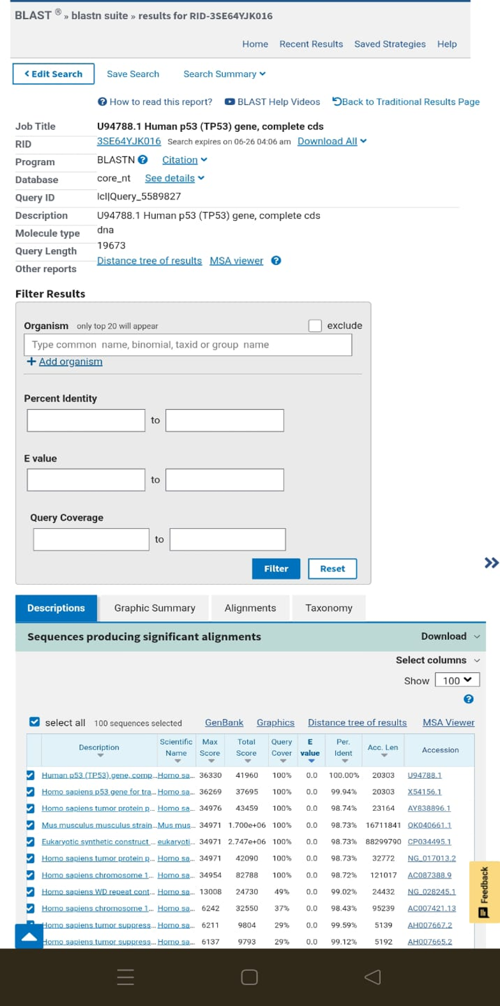

Task 5

5 homologous sequences from different organisms are selected.
- Homo sapiens (Humans)
- Pan troglodytes (chimpanzee)
- Gorilla gorilla ( Gorilla)
- Pan paniscus (Bonobo)
- Nomascus leucogenys (northern white-cheeked gibbon)

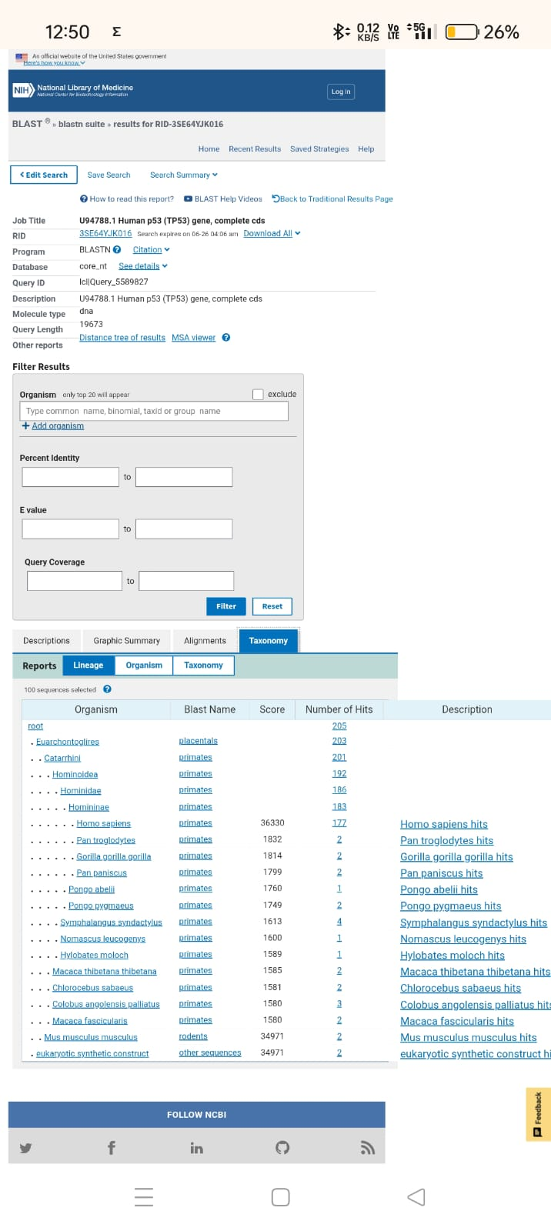

Task 6

Best non-human BLAST hit - Pan troglodytes (chimpanzee)
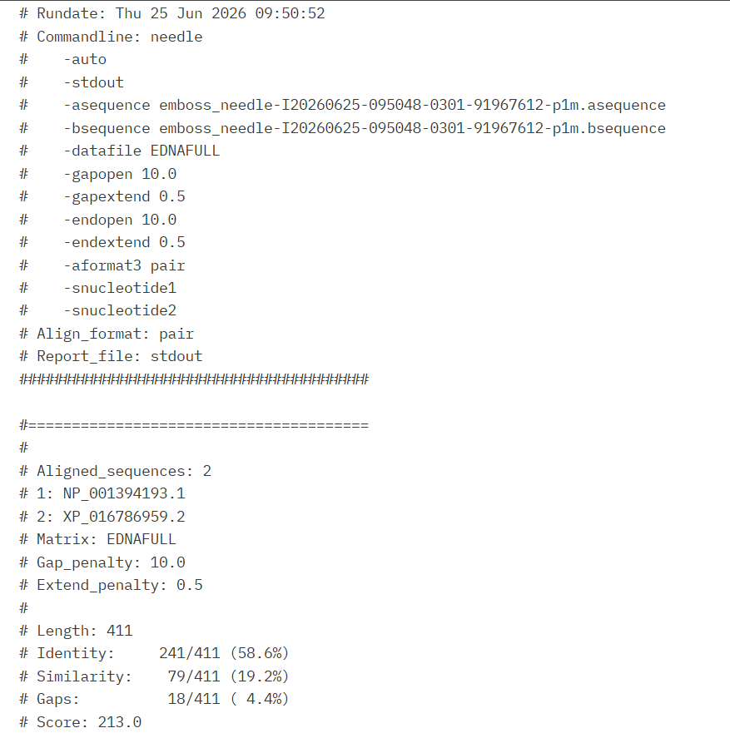

Results
Tool used: EMBOSS Needle
Alignment type: Global pairwise alignment
Sequence 1: NP_001394193.1
Sequence 2: XP_016786959.2
Matrix used: EBLOSUM62
Gap penalty: 10.0
Extend penalty: 0.5

Alignment length: 412 amino acids
Identity: 375/412 = 91.0%
Similarity: 377/412 = 91.5%
Gaps: 20/412 = 4.9%
Alignment score: 1983.5

Why are these sequences highly similar?
- These sequences share significant similarities since TP53 is an essential tumor suppressor gene. The protein encoded by the gene, p53, is involved in DNA repair, cell cycle arrest, and apoptosis processes. Since these activities are vital to cells, the protein sequence is well-conserved through the course of evolution.

Does the result agree with BLAST findings?
- Yes. This is correct based on the results of the EMBOSS Needle comparison. BLAST gave significant similarities among TP53 sequences, while pairwise comparison also gives significant identity and similarities among the chosen protein sequences.

Task 7
Input sequences:
- Human (Homo sapiens)
- Chimpanzee (Pan troglodytes)
- Gorilla (Gorilla gorilla)
- Bonobo (Pan paniscus)
- Northern white-cheeked gibbon (Nomascus leucogenys)

1. Are there regions conserved across all organisms?
Yes. There were a number of highly conserved regions identified within the TP53 protein sequences in primates using the multiple sequence alignment. The identical sequences of amino acids marked by the * signs show the high degree of conservation in the p53 protein sequence.

2. Why might these regions be conserved?
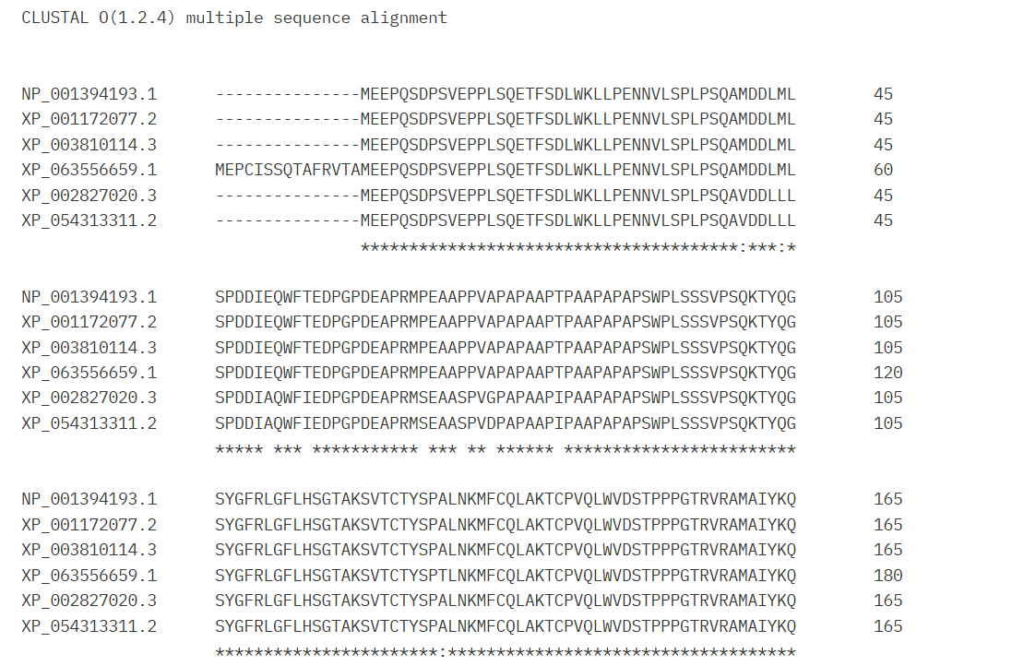
The conserved regions are necessary for the functioning of the p53 protein. These regions have roles in DNA binding, transcriptional activity, cell cycle arrest, DNA repair, and apoptosis. Because these functions are important for the maintenance of genome stability and prevention of tumorigenesis, evolution has maintained these amino acid sequences among closely related organisms.

Task 8
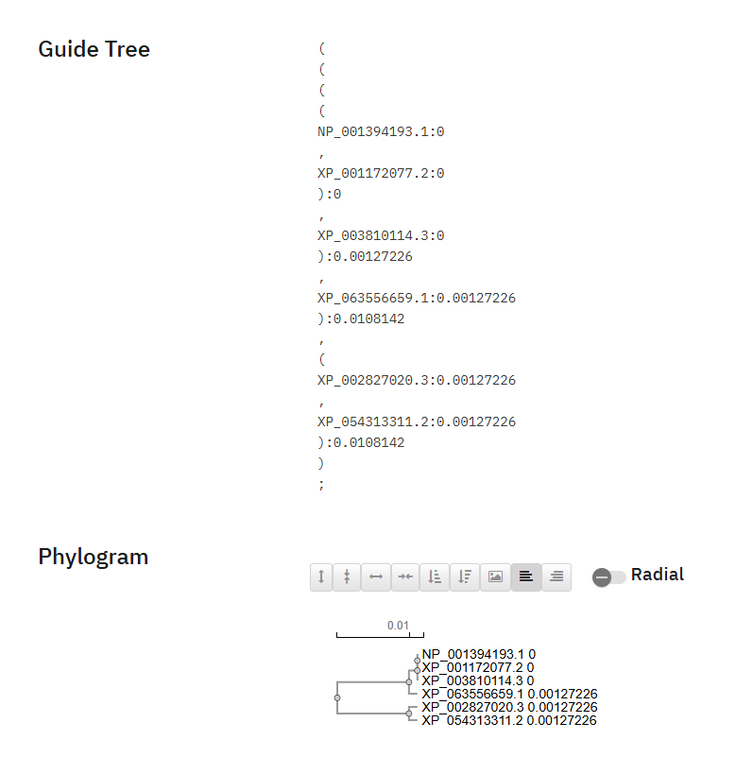
1. Which sequences were grouped together first?
The human (Homo sapiens) and chimpanzee (Pan troglodytes) TP53 protein sequences were grouped together first, indicating the highest sequence similarity.

2. Which organisms appear most similar?
The human (Homo sapiens) and chimpanzee (Pan troglodytes) appear to be the most similar. Their TP53 protein sequences clustered together with essentially no branch separation, reflecting their close evolutionary relationship.

3. Which organism appears most distant?
The northern white-cheeked gibbon (Nomascus leucogenys) appears to be the most distant organism among the selected species because its sequence forms the most separate branch in the guide tree.

Task 9
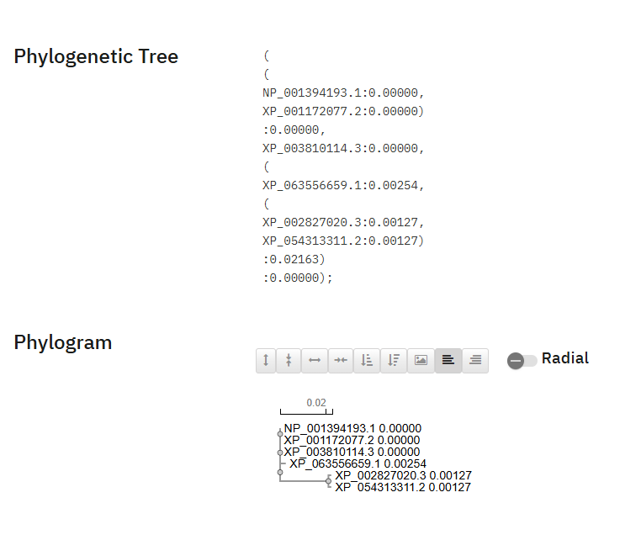
Does the phylogenetic tree support the conclusions obtained from BLAST, EMBOSS Needle, and the Guide Tree?
Explain.
Yes, the phylogenetic tree confirms the results of BLAST, EMBOSS Needle, and Guide Tree.

The phylogenetic tree proves that the human TP53 protein sequence (NP_001394193.1) is clustered with the chimpanzee TP53 sequence (XP_001172077.2). The gorilla and bonobo TP53 sequences are also clustered in the same primate cluster. However, the most distant species in this case is the northern white-cheeked gibbon. The clustering of the sequences represents the evolutionary relationships of the selected species.

The results confirm those from previous studies:

- BLAST: Found very high sequence similarities among TP53 sequences, proving that TP53 is a highly conserved gene.
- EMBOSS Needle: Proved that the sequence identity was 91.0% and sequence similarity was 91.5%, thus, the human and chimpanzee p53 protein sequences have very high homology.
- Guide Tree: First clustered the human and chimpanzee sequences, with the gibbon being the most distant species among the selected ones.
- Phylogenetic Tree: Confirms the evolutionary relationships found by the previous methods.

Task 10
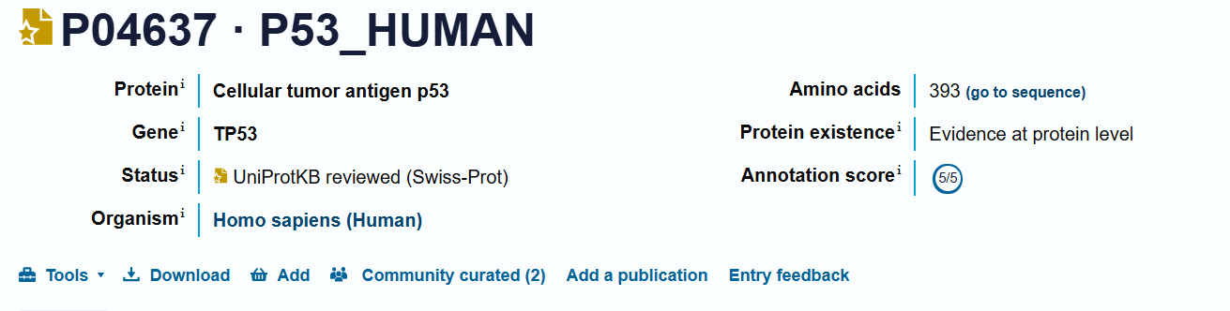

Parameter | Result
Protein Name | Cellular tumor antigen p53
Gene Name | TP53
Organism | Homo sapiens (Human)
Protein Length | 393 amino acids
Annotation Score | 5/5
Evidence Level | Evidence at protein level

Functions of Protein

The cellular tumor antigen p53 is a tumor suppressor protein that acts as the “Guardian of the Genome,” since it performs very important functions which help maintain the genome stability. Some of the important roles that the p53 protein plays are:

Repairing DNA damage
Blocking cell cycle
Induction of apoptosis (cell death)
Inducing cellular senescence
Inhibiting tumor formation

Why might the conserved regions observed in the MSA be important for the function of this protein?
The conserved segments that have been determined through multiple sequence alignment play an important role in the functioning of the p53 protein. In these conserved segments, we find some functionally important segments, namely the DNA-binding segment, which helps the protein p53 to attach itself to specific DNA segments, regulating the genes responsible for DNA repair, cell cycle arrest, and apoptosis. As all these biological activities are very important for genome stabilization and prevention of cancers, natural selection has preserved these amino acids sequences in different organisms. Mutations of these conserved segments result in the improper functioning of the p53 protein, making the organism prone to cancer.

Task 11

NCBI
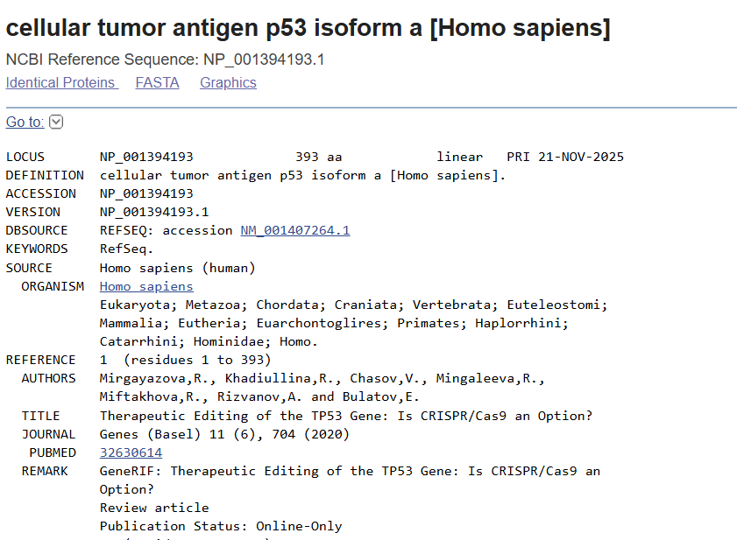

ENA 3. DDBJ

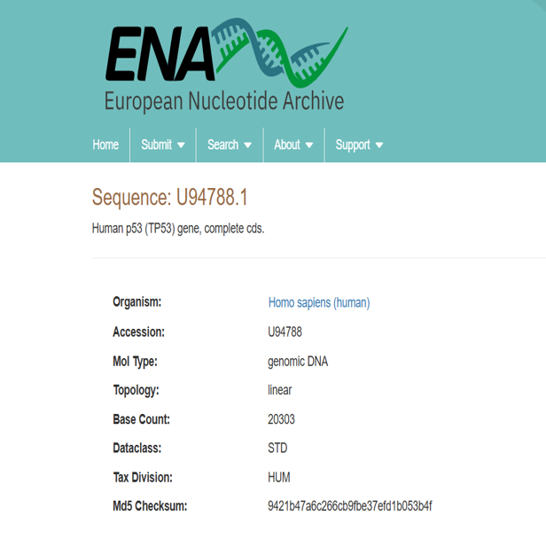
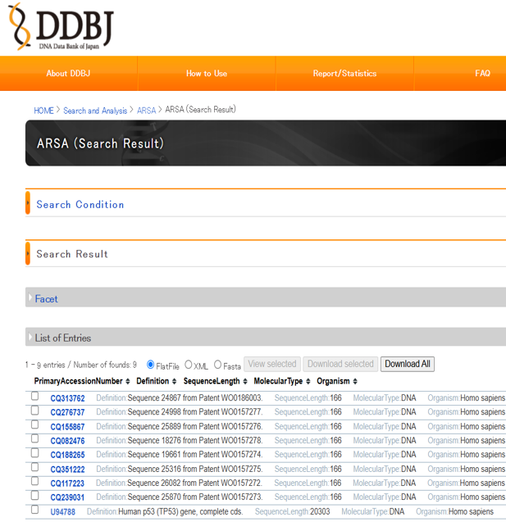

Database | Accession Number | Organism | Sequence Information
NCBI | U94788 | Homo sapiens | Human p53 (TP53) gene, complete coding sequence (CDS); genomic DNA; 20,303 bp
ENA | U94788.1 | Homo sapiens | Human p53 (TP53) gene, complete coding sequence (CDS); genomic DNA; 20,303 bp
DDBJ | U94788 | Homo sapiens | Human p53 (TP53) gene, complete coding sequence (CDS); genomic DNA; 20,303 bp

- Were you able to find the same record in all three databases?
Yes. The TP53 gene sequence with accession number U94788 has been retrieved from NCBI, ENA, and DDBJ. The same accession number, organism (Homo sapiens), and sequence data were available in all three databases, which is evident from the fact that they maintain synchronized nucleotide sequence data.

- Why is the same sequence available in NCBI, ENA, and DDBJ?

Explain the role of INSDC.
The TP53 sequence is also available in NCBI, ENA, and DDBJ because all these databases belong to the International Nucleotide Sequence Database Collaboration (INSDC).

The INSDC comprises an international partnership among the following three databases:

NCBI (National Center for Biotechnology Information, USA)
ENA (European Nucleotide Archive, Europe)
DDBJ (DNA Data Bank of Japan)

The main purpose of the INSDC is to facilitate the collection, archiving, and distribution of nucleotide sequences contributed by researchers all around the world. Every time there is submission of a nucleotide sequence in one of the INSDC databases, it is distributed to both the other databases using the same accession number. It ensures free availability of the same nucleotide sequence data for the researchers around the world irrespective of the database they are using.

Task 12

1. What is the biological function of your selected gene?
The TP53 gene codes for the p53 protein, a tumor-suppressor protein known as the "Guardian of the Genome." This protein controls the cell cycle, ensures DNA repair, apoptosis, and cellular senescence in case of DNA damage or cellular stress. All these mechanisms contribute to maintaining genome integrity and preventing cancer.

2. Which organism is most closely related to humans according to your analysis?
From the analysis done using BLAST, EMBOSS Needle, Clustal Omega, Guide Tree, and Phylogenetic Tree, it can be determined that the chimpanzee (Pan troglodytes) is the most closely related to humans. This is seen from the high similarity in TP53 genes and grouping of humans and chimps in both guide tree and phylogenetic tree.

3. Which regions of the sequence appear highly conserved?
The above regions are conserved due to their involvement in important biological processes such as DNA binding, regulation of transcription, cell cycle arrest, DNA repair, and apoptosis. Mutation in these functional domains may reduce the functioning of the p53 protein leading to an increased risk of cancer. Therefore, there was natural selection of these sequences during evolution.

4. Why are those regions likely conserved during evolution?
This is because these sequences are important for performing various functions such as DNA binding, regulation of gene expression, arresting of the cell cycle, DNA repair, and apoptosis. Mutation of these functional sequences would affect the activity of the p53 protein, making the individual susceptible to cancer. For this reason, natural selection has maintained these sequences during evolution.

5. Did BLAST, EMBOSS Needle, Clustal Omega, Guide Tree, and Phylogenetic Tree produce consistent results?
Yes. Consistent results were obtained from all five bioinformatics analyses performed on the TP53 gene. The sequences found to be very similar were detected by BLAST within the group of primates. High sequence identity was observed by EMBOSS Needle in the case of human and chimpanzee p53 protein. Extensive sequence conservation was observed by Clustal Omega analysis and guide tree analysis.

6. What did this project teach you about sequence conservation, protein function, and evolution?
This research project illustrated how bioinformatics techniques could be combined to analyze the structure of genes, the functions of proteins, and their evolution. It has been revealed that biologically important genes, such as TP53, demonstrate high conservation in organisms belonging to a certain group. This research project also illustrated how similarity of sequences could indicate an evolutionary connection and the importance of conserved proteins for functioning in the living body. Thus, the project offered practical skills in working with bioinformatics databases and analysis tools.

